## CHAPTER 1

**INTRODUCTION**

According to the survey of the World Health Organization (WHO) estimates that in 2017 there were 253 million people visually impaired around the world. In spite of the fact that the number of blindness cases has been significantly reduced in recent years, it is estimated that 81% of the cases of visual impairment are preventable or treatable [1].

Nowadays Diabetic retinopathy (DR) is one of the most frequent causes of blindness and vision loss. In addition, this disease will experience a high growth in the future due to diabetes incidence increase and ageing population in the current society. Its early diagnosis allows, through appropriate treatment, to reduce costs generated when they are in advanced states and may become chronic [2].

A screening campaign requires a heavy workload for trained expert in the analysis of anomalous patterns of each disease which, added to the at-risk population increase, makes these campaigns economically infeasible. Therefore, the need for automatic screening systems is highlighted. Based on these facts, a computer-aided diagnostic software capable of discriminating, through image processing, between a healthy fundus (without any pathology) and DR patients was developed. The high resolution of digital fundus images, they can be automatically processed providing invaluable help to clinicians in early diagnosis and disease prevention. Specifically, the final aim of the software proposed in this project is to be used in an automatic screening of these diseases making the at-risk population assessment possible.

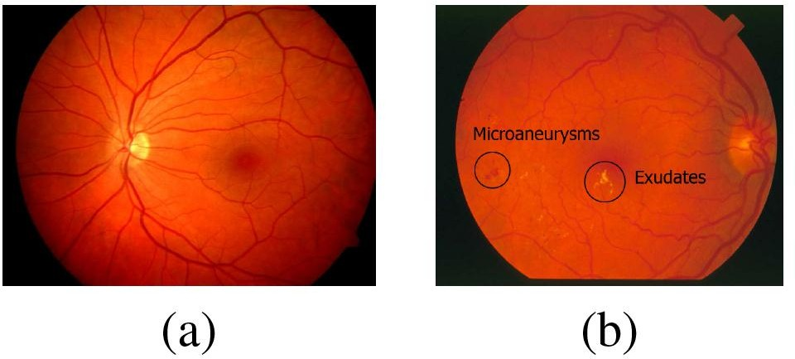

#### Fig 1.1 Fundus images. (a) Healthy, (b) DR (with microaneurysms and Exudates)

Diabetic Retinopathy can be characterized by the presence of specific types of retinal lesions such as microaneurysms and exudates, among others. Fig 1.1 depicts some examples of this disease in comparison with the fundus image from a healthy patient.

This project investigates discrimination capabilities in the Texture of funds to differentiate between pathological and healthy images. In particular, the main focus lies in exploring the performance of Local Binary Patterns (LBP) as a texture descriptor for retinal images. LBP technique has been given a lot of attention in recent years. It is based on looking at the local variations around each pixel, and assigning labels to different local patterns. Thereafter, the distribution of the labels is evaluated and used in the classification stage. There are many examples of the success of LBP used to describe and classify textures in general and also in the case of medical imaging. Regarding fundus image processing, LBP have not been widely used. Most state of the art works that use the LBP technique of fundus images focus on the segmentation of the retinal vessels rather than on a full diagnosis system, although some examples can be found in this direction [3].

## CHAPTER 2

**LITERATURE SURVEY**

#### “Demographic classification with local binary patterns” – Z. Yang and H. Ai

LBP (Local Binary Pattern) is an image operator that is used to extract LBPH (LBP histogram) features for texture description, a novel method to use LBPH feature in the ordinary binary classification problem. Given a restricted local patch, the Chi square distance between the extracted LBPH and a reference histogram is used as a measure of confidence belonging to the reference class, and an optimal reference histogram is obtained by iteratively optimization; the Real AdaBoost algorithm is used to learn a sequence of best local features iteratively and combine them into a strong classifier. The experiments on age, gender and ethnicity classification demonstrate its effectiveness. Maintaining the Integrity of the Specifications [4].

#### “A generalized local binary pattern operator for multiresolution gray scale and rotation invariant texture classification” – T. Ojala, M. Pietikinen, and T. Menp

This paper presents generalizations to the grayscale and rotation invariant texture classification method based on local binary patterns that we have recently introduced. We derive a generalized presentation that allows for realizing a gray scale and rotation invariant LBP operator for any quantization of the angular space and for any spatial resolution, and present a method for combining multiple operators for multiresolution analysis. Another advantage is computational simplicity, as the operator can be realized with a few operations in a small neighborhood and a lookup table. Excellent experimental results obtained in a true problem of rotation invariance, where the classifier is trained at one particular rotation angle and tested with samples from other rotation angles, demonstrate that good discrimination can be achieved with the occurrence statistics of simple rotation invariant local binary patterns. These operators characterize the spatial configuration of local image texture and the performance can be further improved by combining them with rotation invariant variance measures that characterize the contrast of local image texture. The joint distributions of these orthogonal measures are shown to be very powerful tools for rotation invariant texture analysis[5].

#### “Retinal vessel segmentation using color image morphology and local binary patterns” – S. Zabihi, M. Delgir, and H.-R. Pourreza

In this paper the author present, an automated retinal vessel extraction algorithm. A multi- scale morphological algorithm is used for local contrast enhancement of color retinal images. This method enhances vessels not only in color images, but also in the three color components of that image. After feature extraction using LBP and spatial image processing, MLP as a classifier segments the pixels into vessels and non-vessels [6].

#### “Local binary patterns variants as texture descriptors for medical image analysis” –

**L. Nanni, A. Lumini, and S. Brahnam**

This paper focuses on the use of image-based machine learning techniques in medical image analysis. In particular, we present some variants of local binary patterns (LBP), which are widely considered the state of the art among texture descriptors. After we provide a detailed review of the literature about existing LBP variants and discuss the most salient approaches, along with their pros and cons, we report new experiments using several LBP-based descriptors and propose a set of novel texture descriptors for the representation of biomedical images. The standard LBP operator is defined as a grayscale invariant texture measure, derived from a general definition of texture in a local neighborhood. Our variants are obtained by considering different shapes for the neighborhood calculation and different encodings for the evaluation of the local gray scale difference. These sets of features are then used for training a machine-learning classifier (a stand-alone support vector machine) [7].

## CONCLUSION:

* + All MA(Micro Aneurysms) like objects are misclassified.
  + Hard to distinguish between healthy and diseased images.
  + In our earlier research, detectors did not provide reassuring results.
  + Manual lesion segmentation is time consuming.

## CHAPTER 3

**DESIGN**

* 1. **REQUIRMENTS**

The materials used in this project are images previously diagnosed. The data set used is composed of images from the database E-OPHTHA.

E-OPHTHA is a database of fundus images, especially designed for diabetic retinopathy screening. It contains 257 images with no lesion, 47 images with exudates and 148 with microaneurysms or small hemorrhages making a total of 174 images with diabetic retinopathy.

All images of the resulting dataset must comply with certain quality criteria. The following causes were considered reasons for exclusion:

1. Images with severe artefacts, for example bright and circular spots produced by some dust in the camera lens.
2. Images affected by a relative large amount of impulsive noise (salt and pepper noise).
3. Vascular network is largely over-segmented by the method presented.
4. Images with a doubtful diagnosis.
5. Images with highlights around the vessels associated with young retinas.
6. 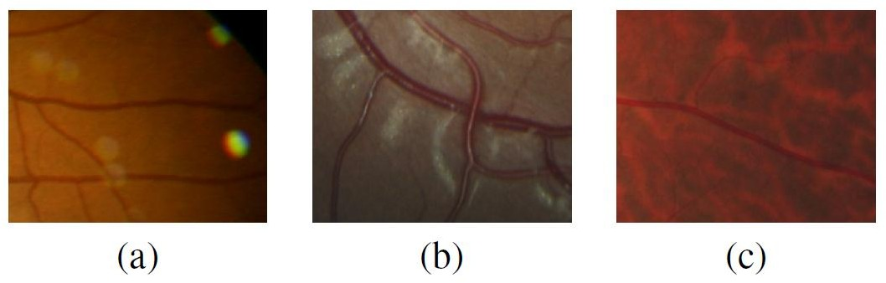Tessellated images due to the fact there are lesser amounts of pigment in the retinal pigment epithelium.

#### Fig 3.1 Excluded images. (a) With artefacts, (b) With highlights and (c) Tessellated.

Fig 3.1 depicts some of these cases. Most of these choices were done to determine if Local Binary Patterns (LBP) were able to discriminate between healthy and pathological images in a normal situation or, in other words, without the presence of distracting elements.

If this hypothesis is confirmed, the method will be expanded in future work to include images of different appearance, for example the tessellated images.

After exclusion, the resulting dataset used in this work is formed by a total of 251 images. This dataset was divided into two subsets, one for training and testing by cross validation (model set) and other purely for testing (validation set). The model set contains 80% of the images and the validation set the remaining 20%.

## LOCAL BINARY PATTERNS

Local binary patterns (LBP) are a powerful grayscale texture operator used in many computer vision applications because of its computational simplicity [3], [4]. The first step in LBP is to produce a label for each pixel in the image where the label is found based on the local neighborhood of the pixel which is defined by a radius, R, and a number of points, P. The neighboring pixels are thresholded with respect to the gray value of the central pixel of the neighborhood, generating a binary string or, in other words, a binary pattern. The value of a Local Binary Patterns (LBP) label is obtained for every pixel by summing the binary string weighted with powers of two as follows:

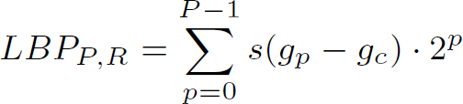

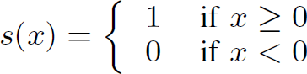



. . . . . . . . . . . . . (1)



Where gp = gray value of neighborhood. gc = gray value of central pixel. P = number of samples.

R = radius of retina image.

Where gp and gc are the gray values of the neighborhood and central pixel, respectively. P represents the number of samples on the symmetric circular neighborhood of radius R. The gp values are interpolated to fit with a given R and P. The values of the labels depend on the size of the neighborhood(P). 2P different binary patterns can be generated in each neighborhood. However, the bits of these patterns must be rotated to the minimum value to achieve a rotation invariant pattern.

When Local Binary Patterns (LBP) are used for texture description, it is common to include a contrast measure by defining the rotational invariant local variance as follows:

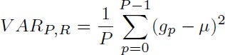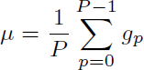



. . . . . . . . . . . . . (2)



. . . . . . . . . . . . . (3)

The Local Binary Patterns (LBP) and VAR measures are complementary and are combined to enhance the performance of the LBP operator. The implementation of both measures is publicly available in the database.

## CHAPTER 4

**METHODOLOGY**

An algorithm for retina image classification without the need for prior segmentation of suspicious lesions was developed. Manual lesion segmentation is time consuming and automatic segmentation algorithms might not be accurate, thus removing the need for lesion segmentation can make the classification more robust. The algorithm is mainly based on the texture analysis of the retina background by means of Local Binary Patterns (LBP).

## PRE-PROCESSING

Due to the fact that the images under study belong to different databases, the size of the images varies. As the Local Binary Patterns (LBP) and VAR values depend on the radius of the neighborhood, the images must be resized to a standardized size to obtain comparable texture descriptors. The images are resized using the length of the horizontal diameter of the fundus. Bicubic interpolation is used for resizing.

Only the pixels of the retina background are considered significant for the texture analysis. Some preliminary tests showed that if these predominant structures were included in the texture analysis, the differences between healthy and pathological images were not appreciated due to the similar aspect of these structures. The optic disc and the vascular network are detected by our own methods. The method used for optic disc detection is mainly based on principal component analysis along with mathematical morphology operations such as stochastic and stratified watershed and geodesic transformations. The algorithm for vessel segmentation combines the use of basic mathematical morphology operations with curvature evaluation. The external mask is directly obtained by thresholding.

Mean Image subtraction or pixel subtraction is a process whereby the digital numeric value of one pixel or whole image is subtracted from another image. This detection of changes can be used to tell if something in the image moved.

ROI can be used as a "mask" to remove pixels from the image. Removing pixels mean setting their intensity to zero.

The dilation operation usually uses a structuring element for probing and expanding the shapes contained in the input image.

The median filter is a nonlinear digital filtering technique, often used to remove noise from an image or signal. Such noise reduction is a typical pre-processing step to improve the results of later processing

Mean value gives the contribution of individual pixel intensity for the entire image& variance is normally used to find how each pixel varies from the neighbouring pixel (or centre pixel) and is used to classify into different regions.

## FEATURE EXTRACTION



**Fig 4.1 Feature Extraction Flowchart**

The Local Binary Patterns (LBP) and VAR operators described above are used to characterize the texture of the retina background. The Local Binary Patterns (LBP) and VAR values corresponding to pixel positions of the optic disc, vessels or outside the fundus are not considered.

The red, green and blue components of each image are independently analyzed. The resulting Local Binary Patterns (LBP) and VAR images provide a description of the image texture. After masking the optic disc and vessel segments, the Local Binary Patterns (LBP) and VAR values within the external mask of the fundus are collected into histograms, one for each color (RGB). Different statistical information is extracted from these histograms to use it as features in the classification stage. Concretely, the calculated statistical values are: mean, standard deviation, median, entropy, skewness and kurtosis. To sum up, 6 statistical values are calculated from each Local Binary Patterns (LBP) and VAR histogram, giving place to 12 features for each radius used. Consequently, the total number of features is equal to 144 (12 features x 4 radius x 3 components). Fig 4.1 depicts the feature extraction flow chart.

## CLASSIFICATION

Once the features are extracted, the data of the model set must be preprocessed before the classification stage. In the preprocessing two tasks are carried out. Data normalization and data resampling. The first one because the range of values of raw data varies widely and the second one because the data set is clearly unbalanced and most machine learning algorithms would not work properly. In particular, the method used for the normalization is to standardize all numeric attribute in the given dataset to have zero mean and unit variance, for the resampling, the Synthetic Minority Oversampling Technique (SMOTE) is applied.

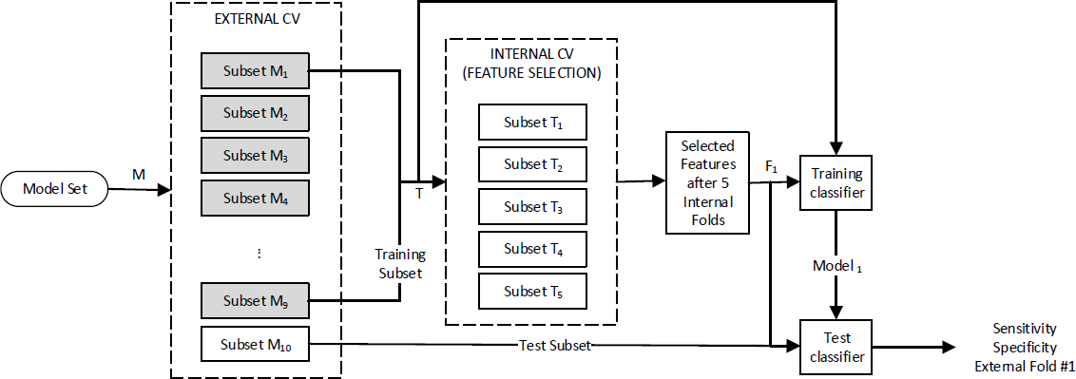



**Fig 4.2 External Cross Validation Flowchart**

Afterwards, external cross validation (CV) also called as nested CV, is performed on the model set so that the dimensionality of the data is reduced by feature selection before being passed on to a classifier. 10 folds are used in the external loop and 5 folds in the internal loop. The purpose of the internal loop is to select a feature subset and the used technique is a wrapper method with forward (best first) selection. The same type of classifier is used in both the internal and external loops. The external loop divides the set into 10 non-overlapping pairs of training (90%) and test (10%) sets. For each fold of the external CV, the training set is further divided into 5 non-overlapping sets by the internal CV loop. The internal loop is done first to select the feature subset of this particular fold of the external loop. Thereafter, the external loop trains the classifier using this subset, and tests it on the remaining 10%. This is repeated for every fold. Notice that the feature set might vary with each external fold of the CV scheme. Thus doing an external or nested CV gives a measure of how well the method works for this dataset, where the method includes the feature subset selector and the choice of classifier. Fig 4.2 shows how the external CV is performed for the first fold.

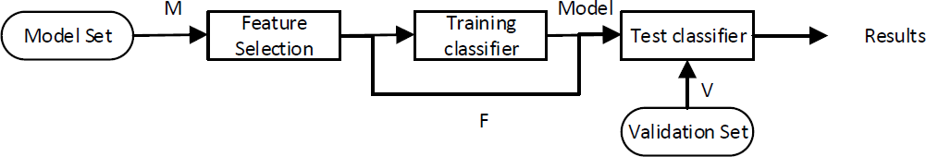



**Fig 4.3 Final Validation Flowchart**

Finally, a final classifier is made using the whole model set for feature subset selection and thereafter the whole model set is used for training the classifier. The validation set is tested on the final classifier. The process is summarized in Fig 4.3. The normalization parameters from the model set are saved as a part of the classifier, such that the validation set is normalized using these same parameters.

## CHAPTER 5

**FLOWCHART AND RESULTS**

* 1. **PROGRAM FLOCHART**

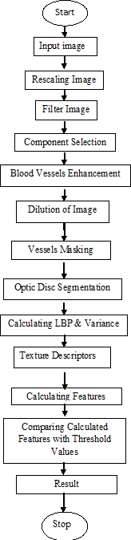

stop

Dilation of Image



**Fig 5.1 Program Flowchart**

* 1. **FLOWCHART DESCRIPTION**
* The random size image (eg 2048*1360, 2544*1696) is rescaled into 512*512 sized image. The rescaling process is based on its horizontal diameter.
* The rescaled image components were extracted into Red, Green and Blue channel images. And again, these images are converted into grayscale images.
* The median filter is applied to each channel image. The median filter is used to remove the noise in the image which can occur while capturing the image.
* In each RGB (Red, Green and Blue) component extracted image the blood vessels are extracted and dilated. After dilation of the image the vessels are masked to remove the vessels.
* In each RGB (Red, Green and Blue) component extracted image the optic disc is masked.
* Applying LBP (Local Binary Patterns) algorithm the LBP and VAR values are calculated for each RGB (Red, Green and Blue) component for different radius.
* After calculating LBP (Local Binary Patterns) and VAR values the feature set is calculated such as Mean, Median, Standard Deviation, Entropy, Skewness and Kurtosis.
* The calculated features are compared with threshold values and then image is classified as diseased or healthy retina image.

## RESULT

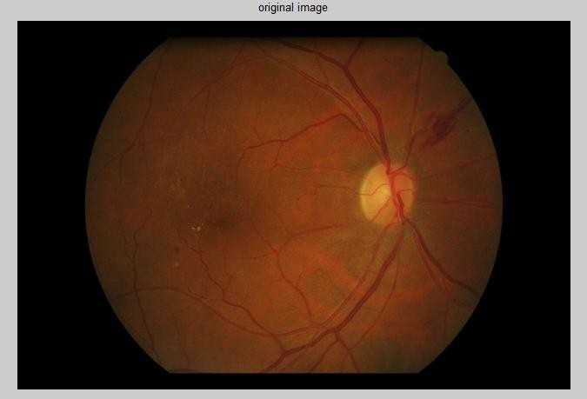



**Fig 5.2 Original image**

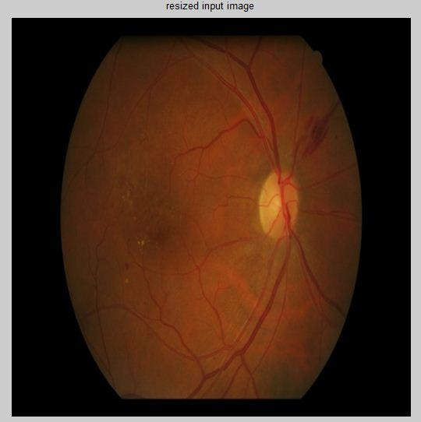



**Fig 5.3 Resized image**



Original random sized image rescaled into 512*512 size image showing in Fig 5.2 and Fig 5.3

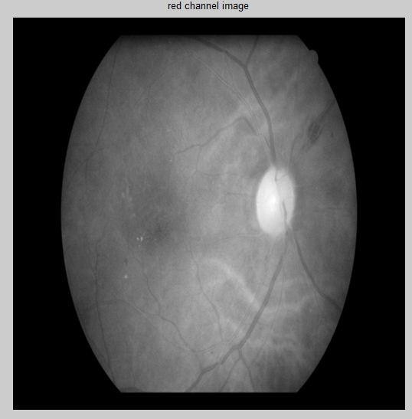 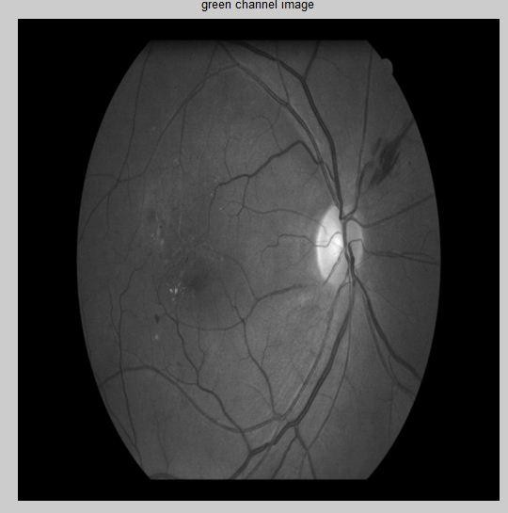

#### Fig 5.4 Red channels Fig 5.5 Green channels

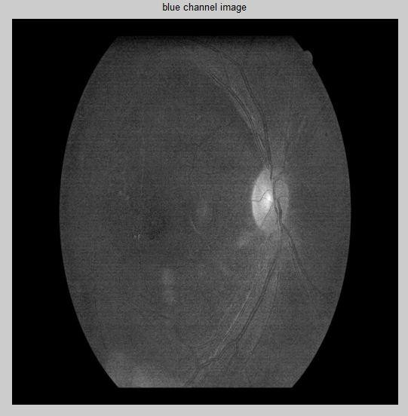



**Fig 5.6 Blue channels**



The rescaled image components were extracted into Red, Green and Blue channel images.

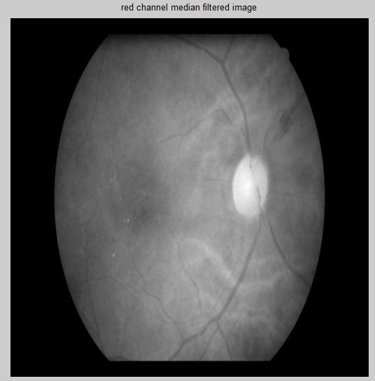

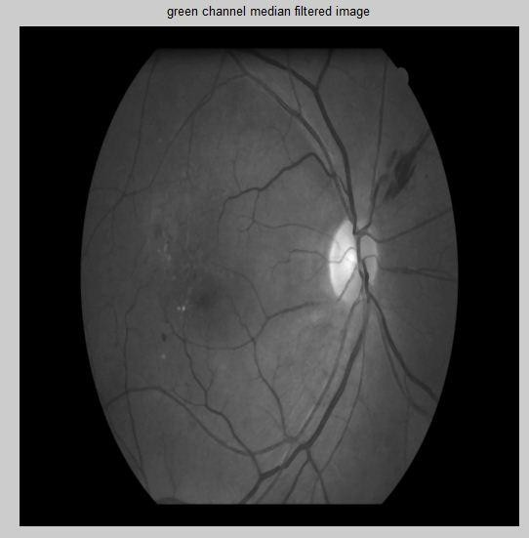

**Fig 5.8 Green channel median filter**



**Fig 5.7 Red channel median filter image**

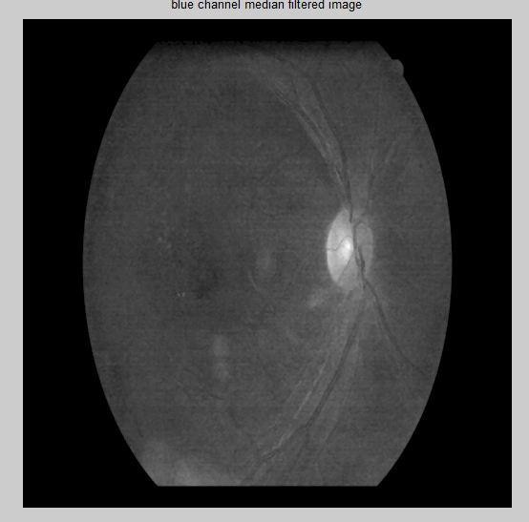



**Fig 5.9 Blue channel median filter image**



The median filter is applied to each channel image. The median filter is used to remove the noise in the image which can occur while capturing the image.

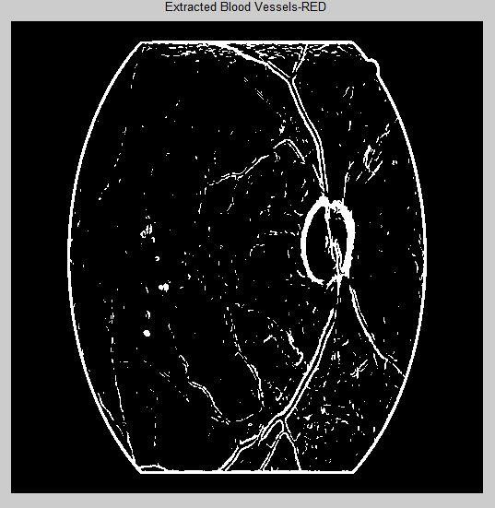 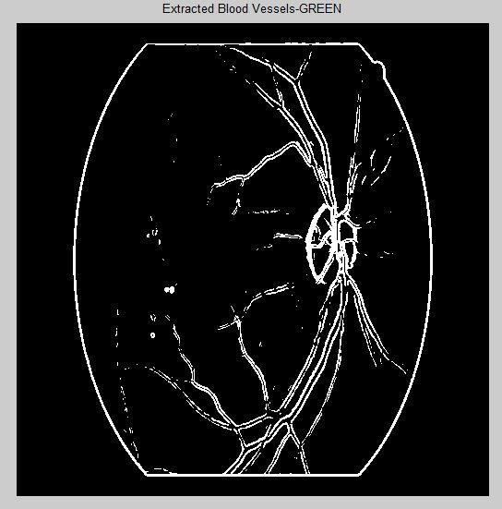



**Fig 5.10 Extracted blood vessels-Red**



**Fig 5.11 Extracted blood vessels-Green**

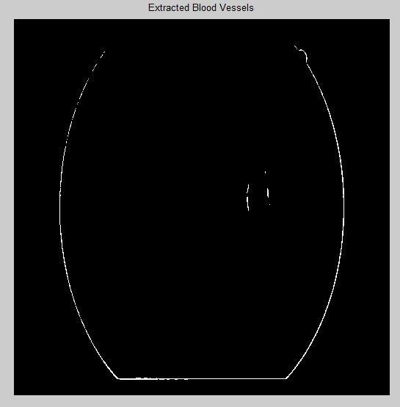



**Fig 5.12 Extracted blood vessels-Blue**



Blood vesels extracted for Red, Green and Blue channel.

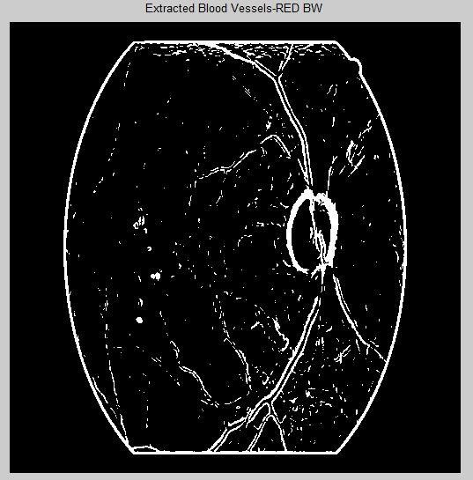 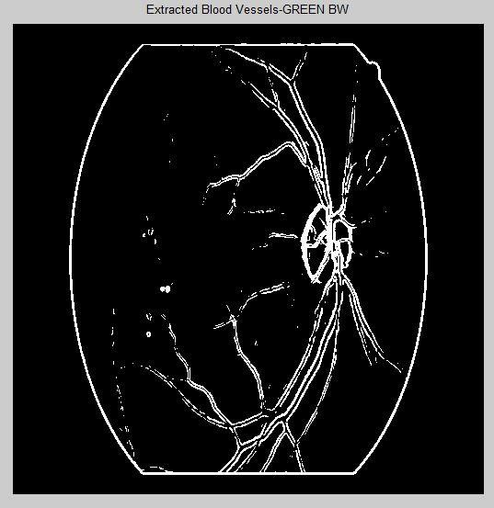



**Fig 5.13 Extracted blood vessels-Red BW Fig 5.14 Extracted blood vessels-Green BW**

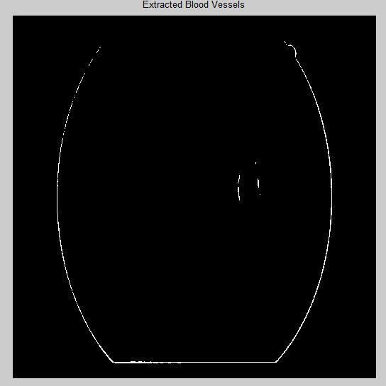



**Fig 5.15 Extracted blood vessels-Blue BW**



Extracted blood vessels are converted into Black and White images.

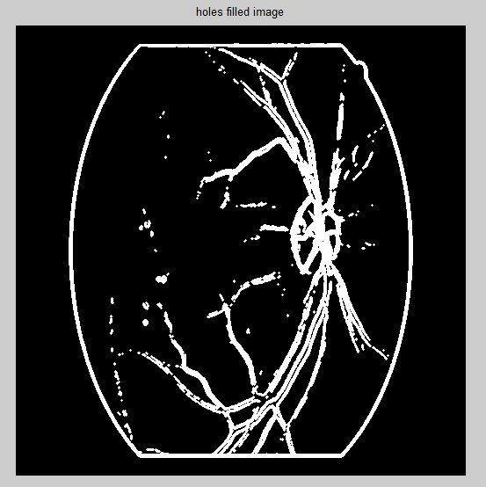

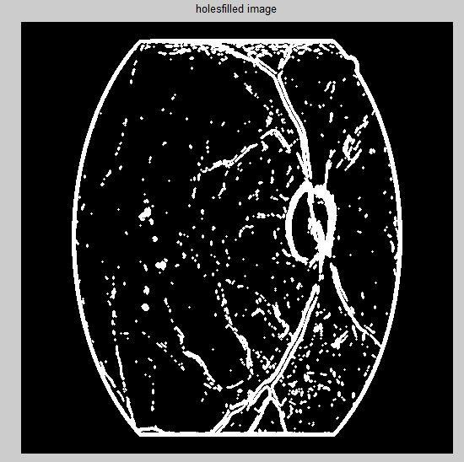

**Fig 5.16 Holes filled image-Red**



**Fig 5.17 Holes filled image-Green**

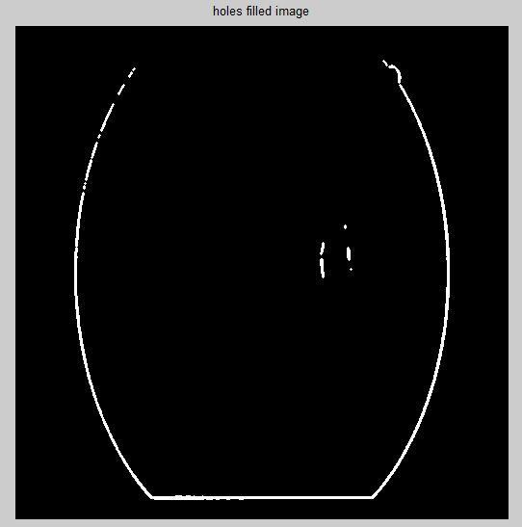



**Fig 5.18 Holes filled image-Blue**



Dilation is a technique used to adding the white pixels to the image for highlighting Blood Vessels.

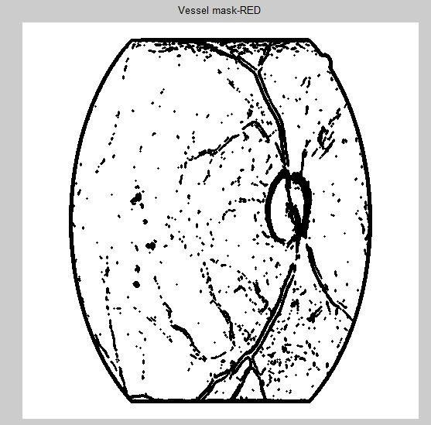 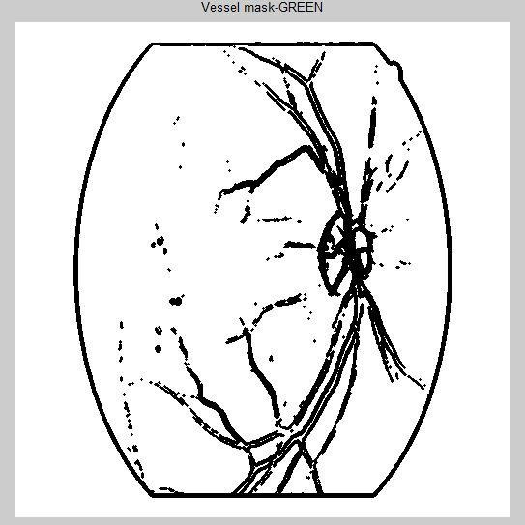



**Fig 5.19 Vessels mask Red**



**Fig 5.20 Vessels mask Green**

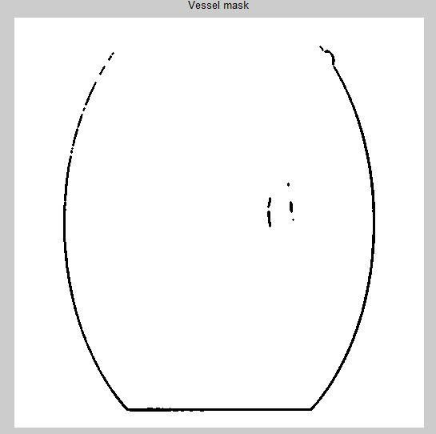



**Fig 5.21 Vessels mask Blue**



Blood vessels are removed hence, the pixel values of blood vessels become zero.

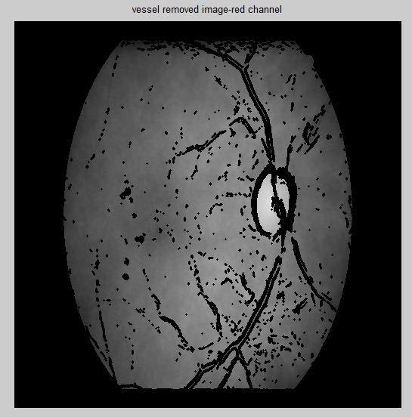 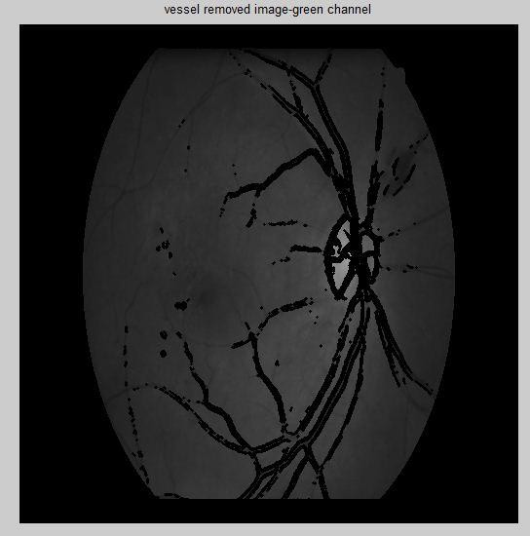



**Fig 5.22 Vessels removed image-Red**



**Fig 5.23 Vessels removed image-Green**

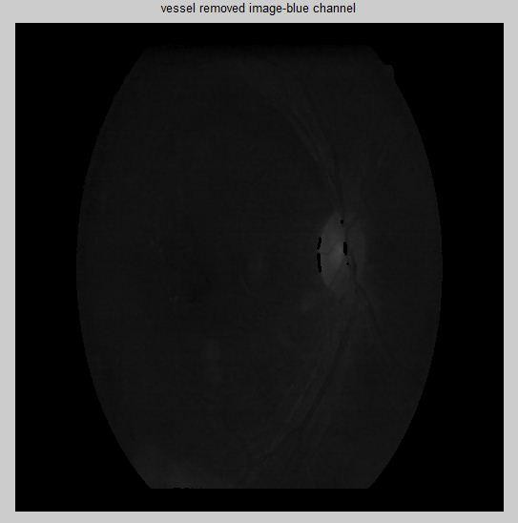



**Fig 5.24 Vessels removed image-Blue**



Removed blood vessel showing in original extracted channel images.

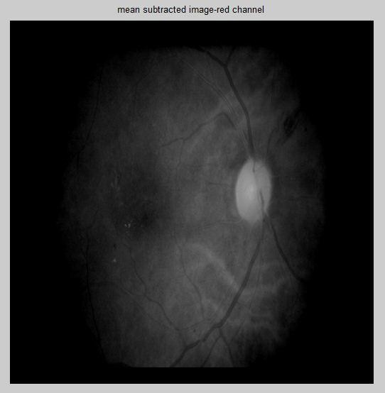 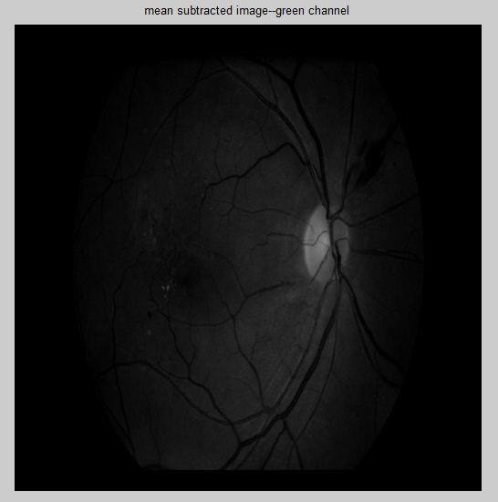



**Fig 5.25 Mean subtracted image-Red**



**Fig 5.26 Mean subtracted image-Green**

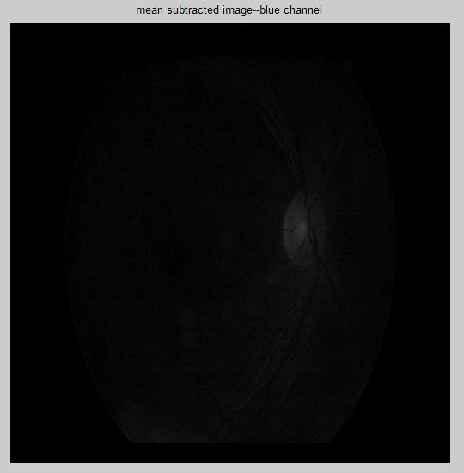



**Fig 5.27 Mean subtracted image-Blue**



Mean subtracted images

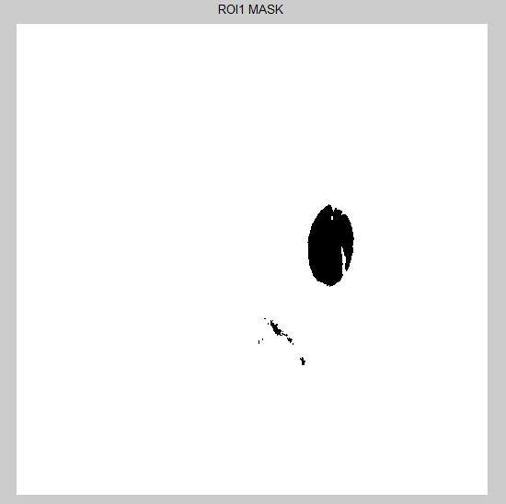 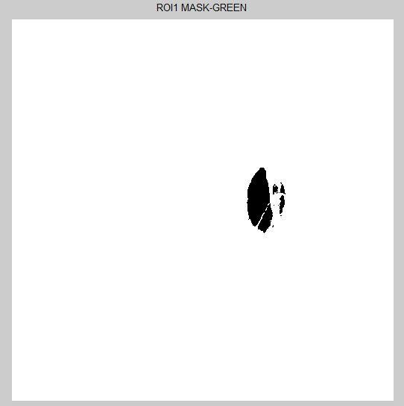



**Fig 5.28 ROI1 Mask-Red**



**Fig 5.29 ROI1 Mask-Green**

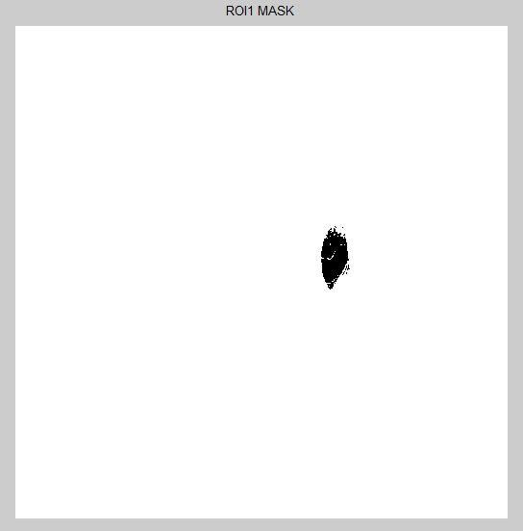



**Fig 5.30 ROI1 Mask-Blue**



ROI masking technique used to remove the optic disc.

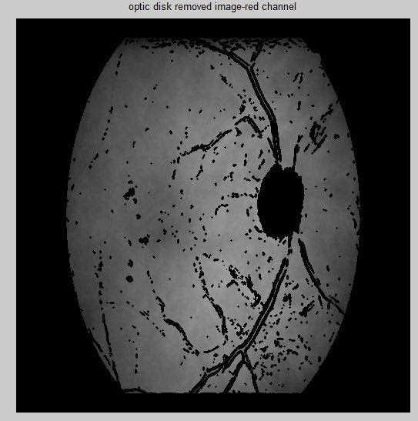 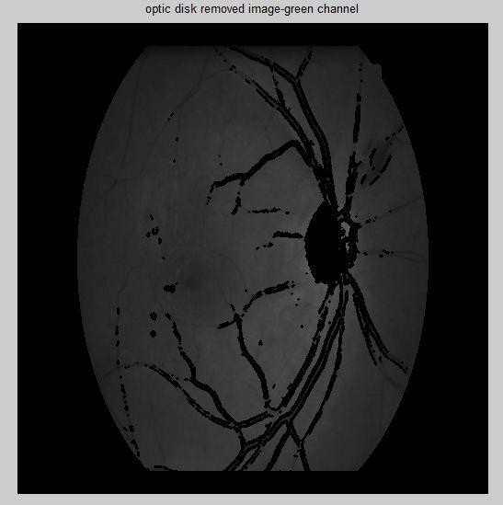



**Fig 5.31 Optic disk removed image-Red**



**Fig 5.32 Optic disk removed image-Green**

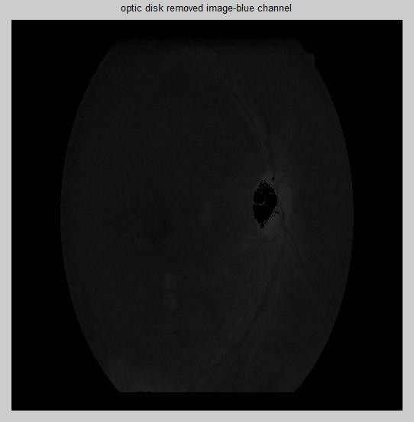



**Fig 5.33 Optic disk removed image-Blue**



In these images optic disc were removed. Here the optic disc pixel value becomes zero.

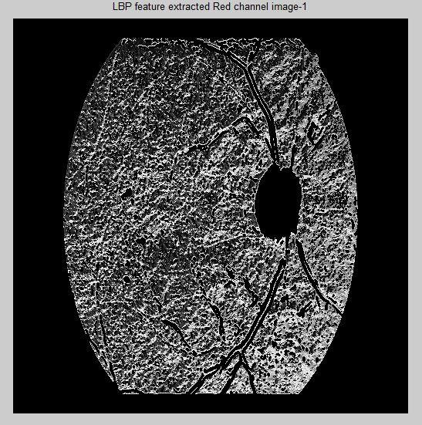 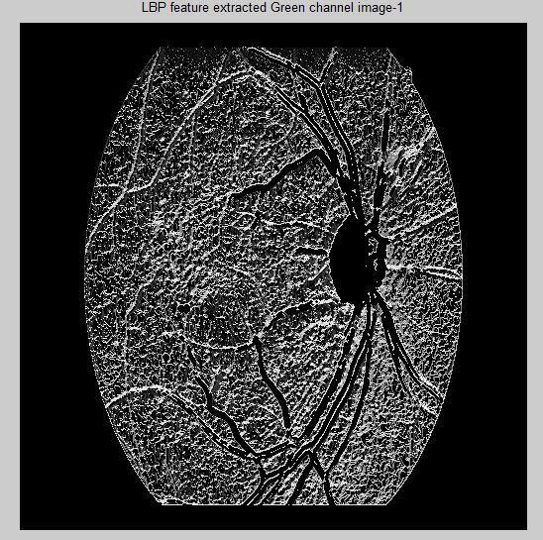



**Fig 5.34 LBP feature extracted Red channel image1**



**Fig 5.35 LBP feature extracted Green channel image1**

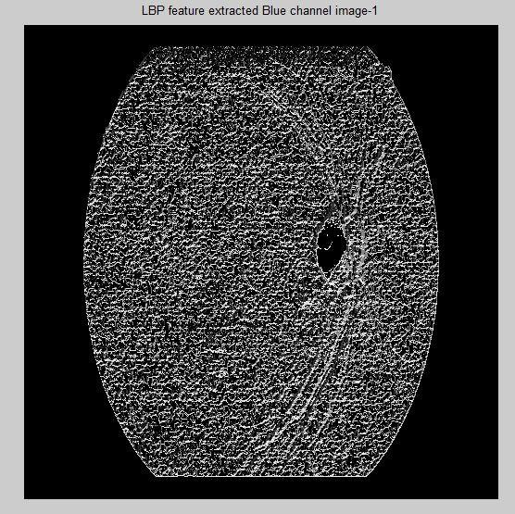



**Fig 5.36 LBP feature extracted Blue channel image1**



In these images for radius R=1 the LBP (Local Binary Patterns) values are calculated.

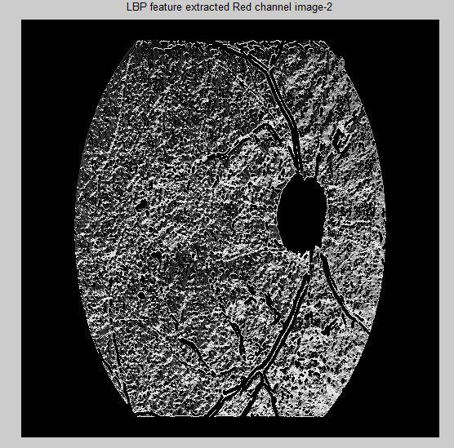 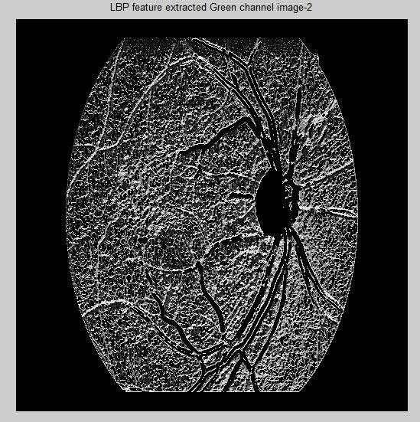



**Fig 5.37 LBP feature extracted Red channel image2**



**Fig 5.38 LBP feature extracted Green channel image2**

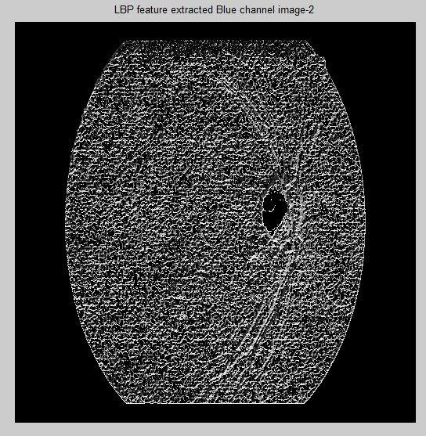



**Fig 5.39 LBP feature extracted Blue channel image2**



In these images for radius R=2 the LBP (Local Binary Patterns) values are calculated.

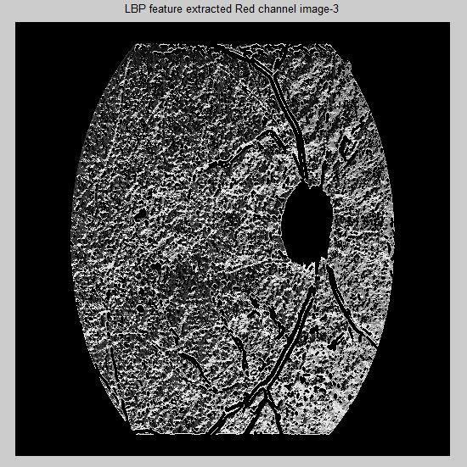 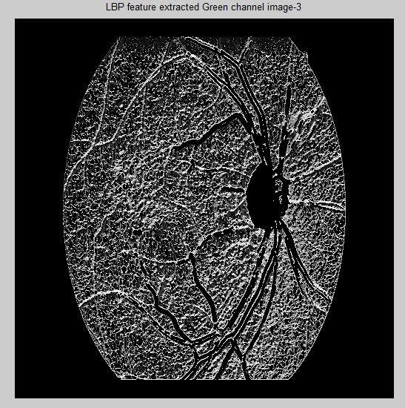



**Fig 5.40 LBP feature extracted Red channel image3**



**Fig 5.41 LBP feature extracted Green channel image3**

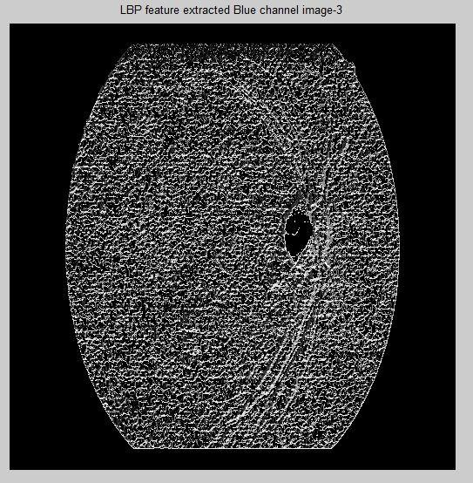



**Fig 5.42 LBP feature extracted blue channel image3**



In these images for radius R=3 the LBP (Local Binary Patterns) values are calculated.

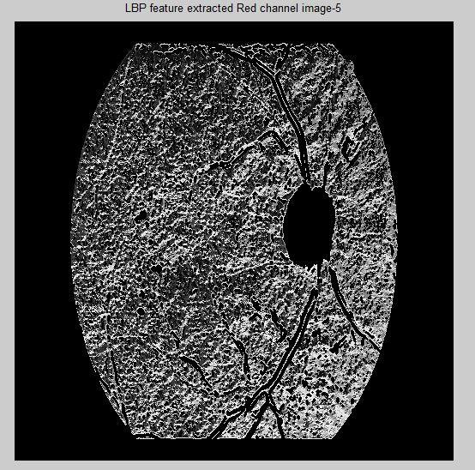 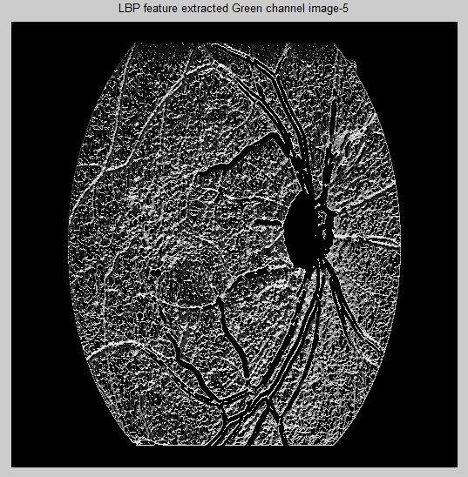



**Fig 5.43 LBP feature extracted Red channel image5**



**Fig 5.44 LBP feature extracted Green channel image5**

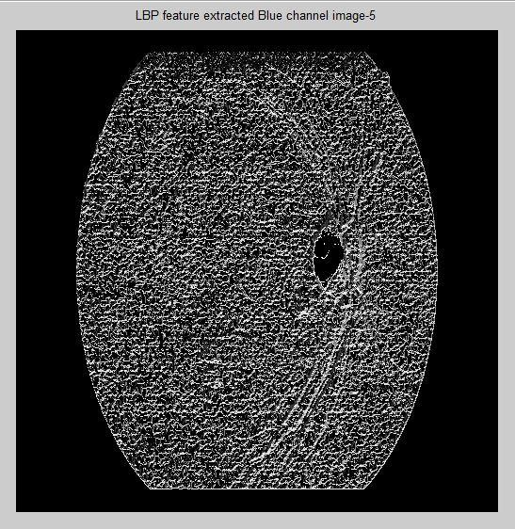



**Fig 5.45 LBP feature extracted Blue channel image5**



In these images for radius R=5 the LBP (Local Binary Patterns) values are calculated.

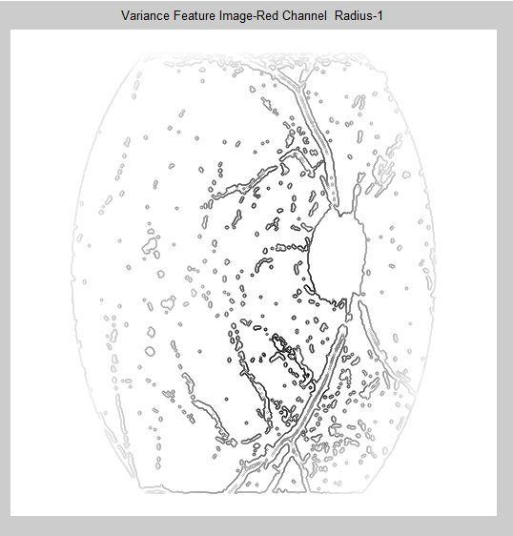 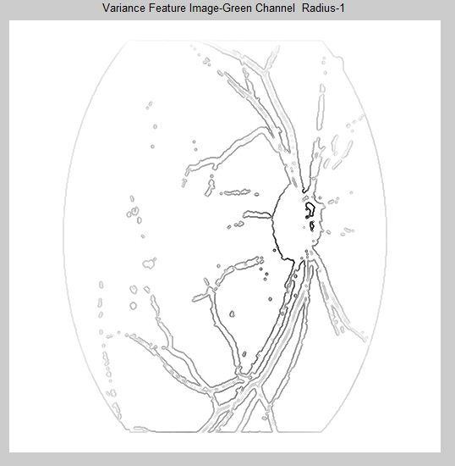



**Fig 5.46 Variance feature image Red channel – radius 1**



**Fig 5.47 Variance feature image Green channel – radius 1**

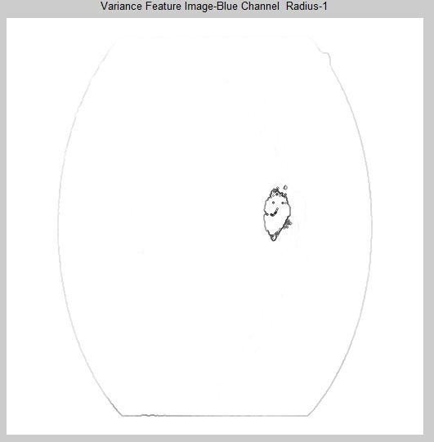



**Fig 5.48 Variance feature image Blue channel – radius 1**



In these images for radius R=1 the variance values are calculated.

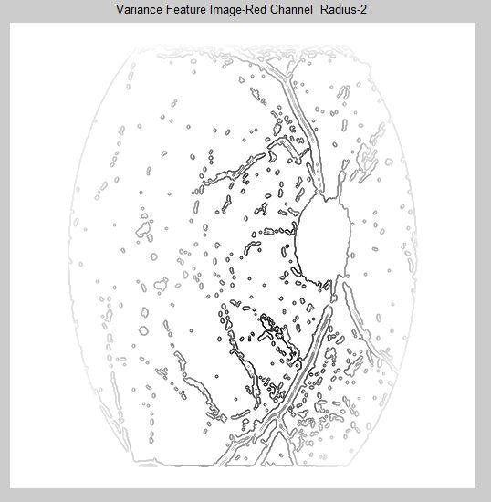 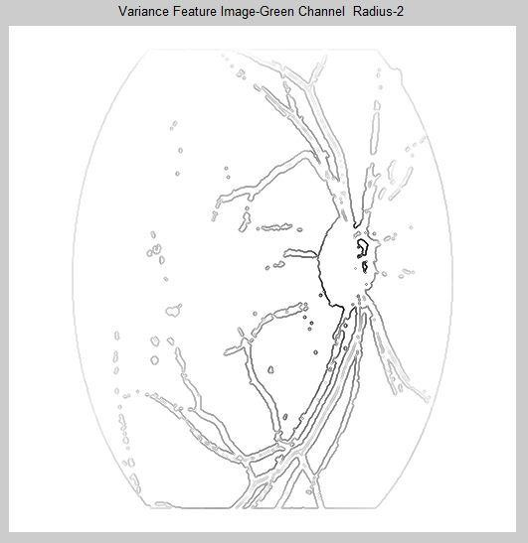



**Fig 5.49 Variance feature image Red channel – radius 2**



**Fig 5.50 Variance feature image Green channel – radius 2**

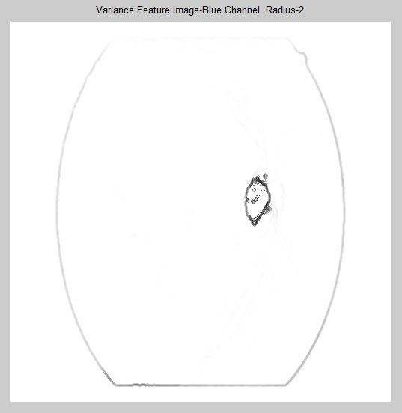



**Fig 5.51 Variance feature image Blue channel – radius 2**



In these images for radius R=2 the variance values are calculated.

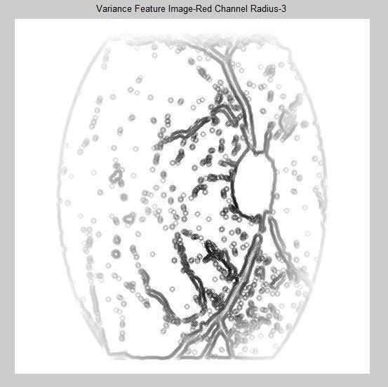 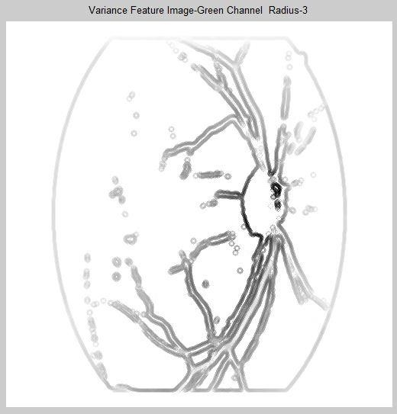



**Fig 5.52 Variance feature image Red channel – radius 3**



**Fig 5.53 Variance feature image Green channel – radius 3**

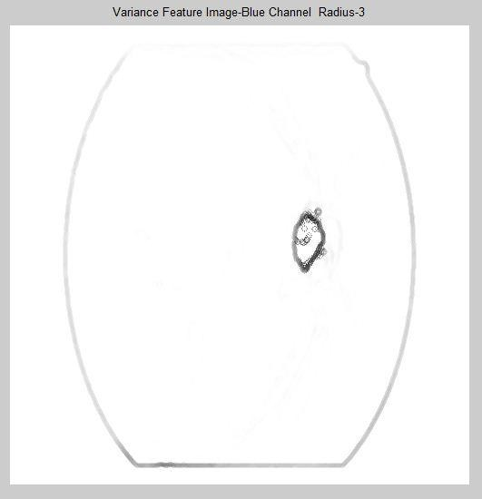



**Fig 5.54 Variance feature image Blue channel – radius 3**



In these images for radius R=3 the variance values are calculated.

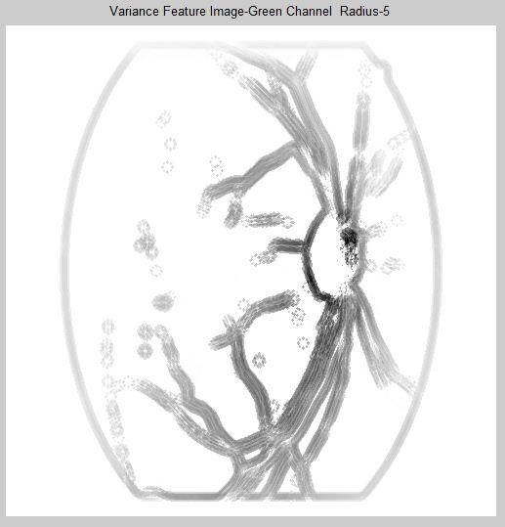

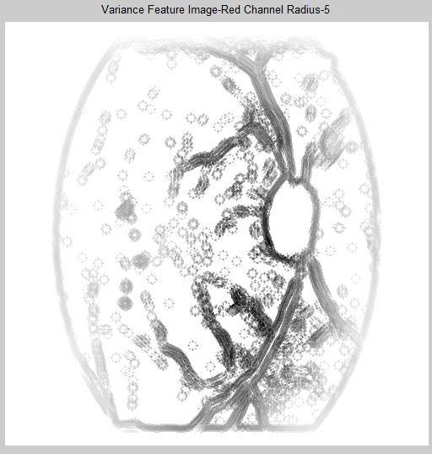

**Fig 5.55 Variance feature image Red channel – radius 5**



**Fig 5.56 Variance feature image Green channel – radius 5**

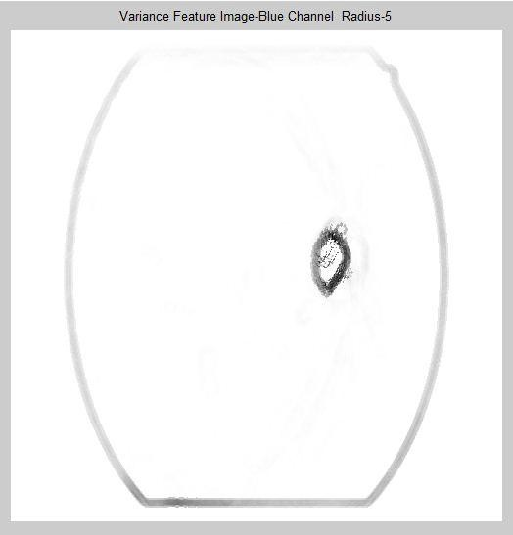



**Fig 5.57 Variance feature image Blue channel – radius 5**



In these images for radius R=5 the variance values are calculated.

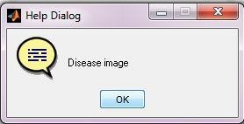



**Fig 5.58 Result Dialog Box**

* **Early stage detection:**

ADVANTAGES

By retinal scanned images disease can’t be observed till it visible. By using this project, the image can be calculated by each pixel value, hence the disease can be monitored in early stage.

### Time consuming:

This project saves the patient and doctors time for observing the patient for disease monitoring.

### Accurate detection:

By comparison with previous detection techniques this project detects accurately.

### High grading performance:

It gives very high grading performance.

### Real time performance:

By taking the images from retinal scanning device, the images can be directly used to detect the disease.

# CONCLUSION

In this project, a new approach to DR (Diabetic Retinopathy) diagnosis was presented. It is based on analyzing texture discrimination capabilities in fundus images to differentiate healthy patients from DR (Diabetic Retinopathy) images. The performance of LBP (Local Binary Patterns) along with different classifiers was tested and compared with other texture descriptors. Here we use 16 healthy images and 8 diseased images, and get total 144 feature extractions for classifying the images. The most important finding is that the proposed method is capable of discriminating the classes based on analyzing the texture of the retina background, avoiding previous segmentation of retinal lesions. Such lesion segmentation algorithms might be both time consuming and potentially inaccurate, thus avoiding the segmentation is beneficial. The obtained results demonstrate that using LBP (Local Binary Patterns) a texture descriptor for fundus images provides useful features for retinal disease screening.

# FUTURE SCOPE

In future work, the stages of the disease can be classified. Moreover, some work should be carried out to develop strategies that enable the analysis of the type of images that were excluded from the initial database, such as tessellated fundus, images with highlights or typical artefacts. Other research line is to automatically determine the presence of biological image variation (tessellation, highlighting or other) prior to the classification step to train different classifiers and use different feature combinations for each specific case. We also wish to explore more texture descriptors. For example, the idea of LBP has been developed further into non-binary coding for texture description, and has provided good results recently. In addition, recent literature describes new texture descriptors based on the co-occurrence method with promising results used for medical images.

# REFERENCES

1. World Health Organization (WHO), “Action plan for the prevention of avoidable blindness and visual impairment 2009-2013,” 2010.
2. World Health Organization (WHO), “Universal eye health: a global action plan 2014- 2019,” 2017. Sandra Morales, Kjersti Enga, Valery Naranjo and Adrian Colomer, “Retinal Disease Screening through Local Binary Patterns” IEEE Journal of Biomedical and Health Informatics.
3. Sandra Morales, Kjersti Enga, Valery Naranjo and Adrian Colomer, “Retinal Disease Screening through Local Binary Patterns” IEEE Journal of Biomedical and Health Informatics.
4. Z. Yang and H. Ai, “Demographic classification with local binary patterns,” in Advances in Biometrics, ser. Lecture Notes in Computer Science, S.-W. Lee and S. Li, Eds., 2007, vol. 4642, pp. 464–473.
5. S. Zabihi, M. Delgir, and H.-R. Pourreza, “Retinal vessel segmentation using color image morphology and local binary patterns,” in Machine Vision and Image Processing (MVIP), 6th Iranian, 2010, pp. 1–5.
6. L. Nanni, A. Lumini, and S. Brahnam, “Local binary patterns variants as texture descriptors for medical image analysis,” Artificial Intelligence in Medicine, vol. 49, no. 2, pp. 117 – 125, 2010.
7. T. Ojala, M. Pietikinen, and T. Menp, “A generalized local binary pattern operator for multiresolution gray scale and rotation invariant texture classification,” in Advances in Pattern Recognition, 2nd International Conference on, 2001, pp. 397–406.

# PUBLICATIONS

Kiran S M, Charith D U, Govind N Pachapure, Srinivas A, Dr Ganashree T S, “Retinal Disease Screening Through Local Binary Patterns”. This paper has been accepted for IJSER (International Journal of Scientific Research), publication ID – IJSRDV6I30746 which is yet to be published.